**DAILY ONLINE ACTIVITIES SUMMARY**

|  |  |  |  |  |  |  |  |  |
| --- | --- | --- | --- | --- | --- | --- | --- | --- |
| **Date:** | **6-6-2020** | | | | | **Name:** | **Prajna** | |
| **Sem & Sec** | **8th sem ‘B’** | | | | | **USN:** | **4AL16CS067** | |
| **Online Test Summary** | | | | | | | | |
| **Subject** | | **IOT** | | | | | | |
| **Max. Marks** | | **30** | | **Score** | | | **30** | |
| **Certification Course Summary** | | | | | | | | |
| **Course** | **Introduction to front end** | | | | | | | |
| **Certificate Provider** | | | **Great Learning** | | **Duration** | | | **30min** |
| **Coding Challenges** | | | | | | | | |
| **Problem Statement:**1**.** Write a c program to covert decimal to binary | | | | | | | | |
| **Status: Completed** | | | | | | | | |
| **Uploaded the report in GitHub**  **GitHub link:** | | | | | **Yes**  **https://github.com/alvas-education-foundation/prajna_k** | | | |
| **If yes Repository name** | | | | | **prajna_k** | | | |
| **Uploaded the report in slack** | | | | | **yes** | | | |

Online Test Details: (Attach the snapshot and briefly write the report for the same)

Certification Course Details: (Attach the snapshot and briefly write the report for the same)

Coding Challenges Details: (Attach the snapshot and briefly write the report for the same)

1)online test

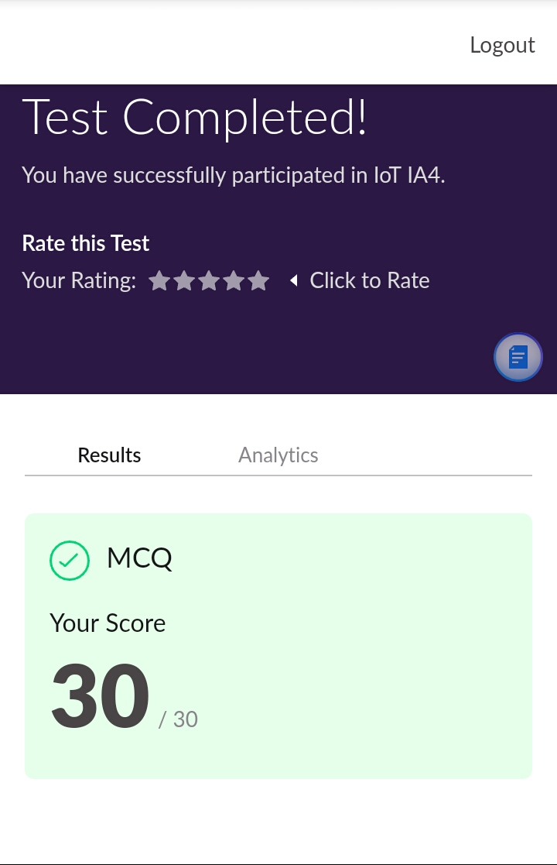

2) certification course

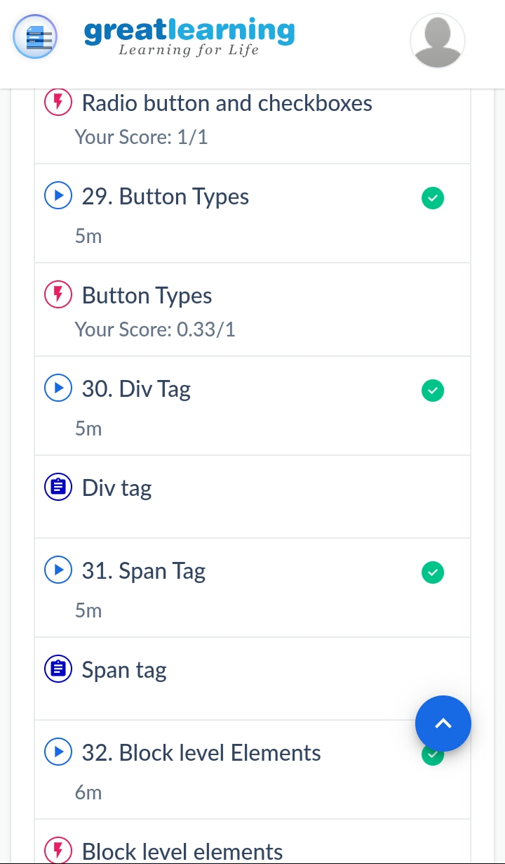

3) coding challenges

Program 1

|  |
| --- |
| #include <stdio.h>  int main()  {  int number,cnt,i;  int bin[32];  printf("Enter decimal number: ");  scanf("%d",&number);  cnt=0;  while(number>0)  {  bin[cnt]=number%2;  number=number/2;  cnt++;  }  printf("Binary value is: ");  for(i=(cnt-1); i>=0;i--)  printf("%d",bin[i]);  return 0;  } |

|  |
| --- |
|  |
|  |  |
|  |  |
|  |  |
|  |  |
|  |  |